41.3: 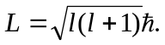 The maximum orbital quantum number 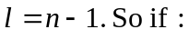
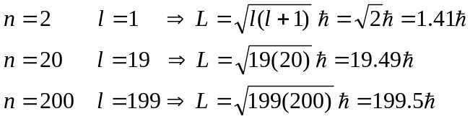
The maximum angular momentum value gets closer to the Bohr model value the larger the value of

